INTRODUCTION TO DRILL AND CEREMONIES\30-STEP DRILL SEQUENCE

Information in this publication is as follows:

1. General information on how to teach the 30-Step Drill Sequence
2. Drill Vocabulary and Terminology
3. 30-Step Drill Sequence (with reporting in and out procedures)
4. Sample Diagram of what a 30-Step Drill Sequence would look like (with 3 element leaders)
5. Fall-in
6. Attention
7. Parade Rest
8. Dress Right Dress (not a 30-step command, but necessary to execute the Open Ranks)
9. Open Ranks (without inspection commands)
10. Close Ranks
11. Present Arms/Order Arms
12. Left Face
13. About Face
14. Right Flank
15. Left Flank
16. Column Right (with 3 element leaders)
17. To the Rear
18. Eyes Right
19. Change Step
20. Right Step

For a complete viewing of how to execute the 30-Step Drill Sequence (complete with inspection after open ranks) is available at the following link on the Air Force Junior ROTC webpage. Please have your cadets review this video on what a 30-Step Drill Sequence should look like. NOTE the flight commander remains on the outside of the flight.

HQ AFJROTC Web Page:

https://www.airuniversity.af.edu/Holm-Center/AFJROTC/Display/Article/1240293/30-step-drill-sequence/

You Tube: https://www.youtube.com/watch?v=dV6Rz-19J5I&t=19s

Other resources available to you: WINGS / Published Files / Directory / JROTC / AFJROTC Curriculum / Drill and Ceremonies (here you can find several lesson plans developed by BMTS Military Training Instructors from Lackland AFB TX.

HOW TO TEACH THE 30-STEP DRILL SEQUENCE
Drill consists of certain movements by which the flight or squadron is moved in an orderly manner from one formation to another or from one place to another.

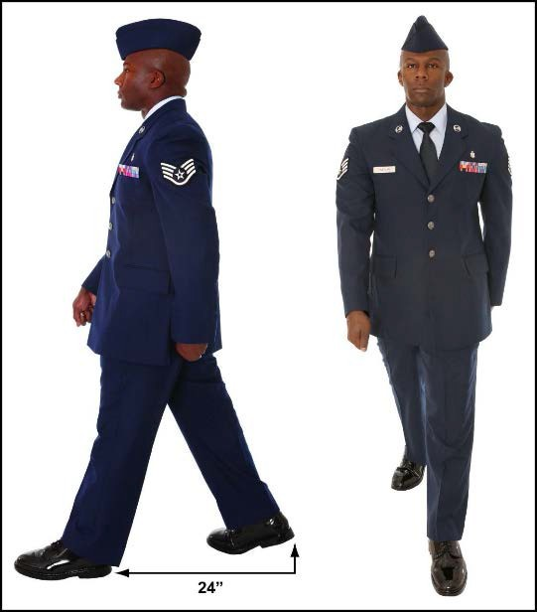
Standards such as:
- 24-inch step, measured from heel to heel; 12-inch step, measured from heel to heel and place the heel of the foot down first.
- Cadence of 100 to 120 steps per minute, distance.
- The swing of the arms will measure 6 inches to the front (measured from the rear of the hand to the front of the thigh) and 3 inches to the rear (measured from the front of the hand to the back of the thigh).
- 40-inch distance, measured from the chest of the individual to the back of the individual directly in front

Your job is to learn these movements and execute each part exactly as described. You must also learn to adapt your own movements to those of the group. Everyone in the formation must move together on command.

The 30-step drill sequence is a significant part of the AFJROTC curriculum and is part of the grading criteria used to conduct unit evaluations. Air Force Manual (AFMAN) 36-2203 is the governing directive for the 30-step drill sequence. Learn, practice, and perfect everything in this manual and you will be a drill MASTER … but you must put forth the effort.

A suggested way to teach the 30-step drill sequence can be broken down into four steps.

  - Require cadets to memorize the sequence and be able to write all 30 steps in order.
  - Once cadets can write the sequence, have them verbally recite the sequence to the entire class.
  - Once cadets can recite the sequence, then break the class down into small groups, approximately 5 cadets in each group and have them practice commanding and the small group executing the first 10 commands. This can be done in the classroom or outside depending on the space you have since these are stationary movements
4. Once cadets master commanding the first 10 commands to their small group, keep the same small groups of 5 and then let cadets practice commanding and marching their group through the rest of the sequence. Each cadet gets a turn at commanding the sequence. You can use upper classmen and members of the drill team to help the cadets with commanding their groups. As always, the groups have SASI/ASI oversight.

DRILL VOCABULARY & TERMINOLOGY
- AFI-- Air Force Instruction
- AFMAN-- Air Force Manual
- IAW-- In Accordance With
- Army Training Curricular - Army TC 3-21.5 (Armed Drill/Color Guard)
- Alignment— Dress or cover
- Cadence— The uniform step and rhythm in marching; that is; the number of steps per minute.
- Cover—Individuals aligning themselves directly behind the person to their immediate front while maintaining proper distance.
- DCID – Dress, Cover, Interval, and Distance
- Distance— The space from front to rear between units. The distance between individuals in a formation is 40 inches as measured from their chests to the backs of individuals directly in front of them.
- Dress—Alignment of elements side by side or in line maintaining proper interval.
- Element— The basic formation; that is, the smallest drill unit comprised of at least 3, but usually 8 to 12 individuals, one of whom is the designated element leader.
- Flank— The extreme right or left (troop’s right or left) side of a formation in line or in column.
- Flight— At least two, but not more than four, elements.
- Interval— The space between individuals placed side by side. A normal interval is an arm’s length. A close interval is 4 inches.
- Mark Time— Marching in place at a rate of 100 to 120 steps per minute.
- Pace— A step of 24 inches. This is the length of a full step in quick time.
- Quick Time— The rate of marching at 100 to 120 steps (12 or 24 inches in length) per minute.
- Rank— A single line of persons placed side by side.
- Step— The distance measured heel to heel between the feet of an individual marching.
- Unit— Any portion of a given formation.

30-STEP DRILL SEQUENCE

The requirement for all second-year cadets is to be able to march. Headquarters AFJROTC has developed a 30-step drill sequence which is required to be executed by all second-year cadets or higher.

Cadet Commander will report in to the inspector, after the command fall-in is given.
Example: Sir/Ma’am, Unit Number, is prepared for the 30-step drill sequence. Request permission to use your drill area, Sir/Ma’am!

30-Step Drill Sequence (Mandatory for all second-year cadets)

1. *Fall in 16. To the rear march
(Sizing of flight/count off is not required for HQ AFJROTC purposes – units may teach these if they wish commands, but they are not required for our purposes)
2. Open ranks march 17. To the rear march
3. Ready front 18. Column right march
4. Close ranks march 19. Forward march
5. Present arms 20. Eyes right (salute the evaluator)
6.Order arms 21. Ready Front
7. Parade rest 22. Column right march
8. Attention 23. Forward march
9. Left face 24. Change step march
10. About face 25. Column right march
11. Forward march 26. Forward march
12. Right flank march 27. Flight halt
13. Left flank march 28. Left face
14. Column right march 29. Right step march
15. Forward march 30. Flight halt

Cadet Commander will report out to the inspector, after the command flight halt is given. Example: Sir/Ma’am, Unit Number, request permission to exit your drill area, Sir/Ma’am!

Remember the 30-step drill sequence is a big box. If cadets can visualize a box, they can successfully lead a group of cadets through the 30-step sequence.

SAMPLE OF 30-STEP DRILL SEQUENCE
USING 3 ELEMENTS
(Fits on a Gym Floor)

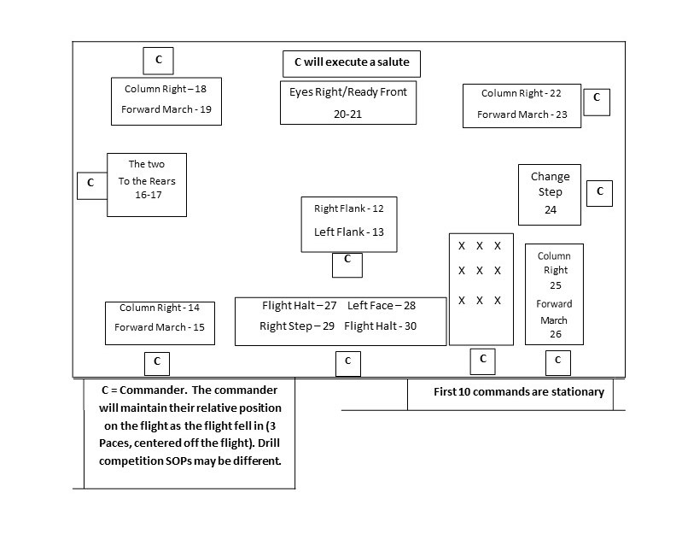

FALL IN
Purpose: “Fall In” is used to form the flight and to establish interval.
Combined Command: “Fall In”
Requirements for Movement: A flight forms in at least two, but not more than four, elements in line formation. This is done in line formation. The command is FALL IN. Cadets will fall in at attention.
- On this command, the guide takes a position facing the flight sergeant and to the flight sergeants left so the first element will fall in centered on and three paces from the flight sergeant. Once halted at the position of attention, the guide performs an automatic dress right dress. When the guide feels the presence of the first element leader on his or her fingertips, the guide executes an automatic ready front. Once positioned, the guide does not move.
- The first element leader falls in directly to the left of the guide and, once halted, executes an automatic dress right dress. The second, and third element leaders fall in behind the first element leader, execute an automatic dress right dress, visually establish a 40-inch distance, measured from the chest of the individual to the back of the individual directly in front and align themselves directly behind the individual in front of them. The remaining cadets fall into any open position to the left of the element leaders and execute an automatic dress right dress to establish dress and cover. It is best practice to fill in remaining spots for each file from back to front (4th element to 1st element) and then start a new file until all cadets are in the formation. This will ensure that any partially filled files will have cadets in the correct location.
- The leading individual of each file establishes normal interval (by taking small choppy steps and aligning with the base file) and establishes exact shoulder-to- fingertip contact with the individual to the immediate right. The second, third, and fourth element leaders align themselves directly behind the person in front of them (using small choppy steps) and visually establish a 40-inch distance.
- To establish interval, the leading individual in each file obtains exact shoulder-to- fingertip contact with the individual to his or her immediate right. As soon as dress, cover, interval, and distance are established, each cadet executes an automatic ready front on an individual basis and remains at the position of attention.
5. Once it is formed, the flight will be squared off prior to sizing. The left flank of the formation will be squared off with extra cadets filling in from the fourth to the first element. For example, if there is one extra cadet, he or she will be positioned in the fourth element; if there are two extra cadets, one will be positioned in the third element and one will be positioned in the fourth element; and so forth.
6. To size the flight, the flight commander faces the flight to the right (from line to column formation) and has taller personnel (except the guide, element leaders) move to the front of the flight according to height. The flight commander then faces the flight to the right (from column to inverted line formation) and again has taller personnel move to the front of the flight according to height. The flight commander faces the flight back to the left (column formation) and continues this procedure until all members are properly sized.
ATTENTION
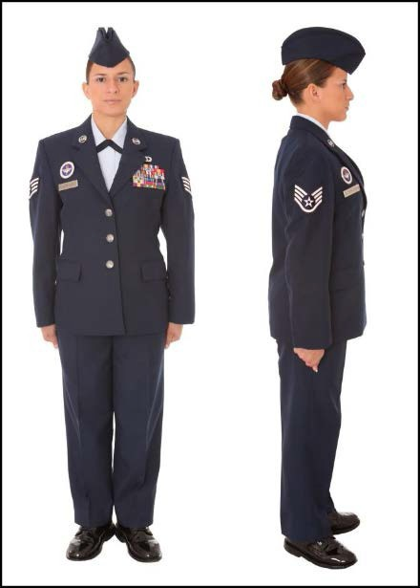
Purpose: The position of attention is the military ready position for drill and inspection; and is the proper position to maintain when being addressed by a ranking officer.
Preparatory Command: “Flight/Detail”
Command of Execution: “Attention”
Requirements for Movement: This movement can be performed as a single individual or with an entire flight. This movement can be performed in any formation, at Close or Normal Interval, in the Cadence of Quick Time, and is executed with snap and pop.

- When you hear the preparatory command of “Flight”, snap to Parade Rest.
- Upon hearing the command of execution, “Attention”, lift the left leg from the hip, just high enough to clear the ground.
- Smartly move the left foot in, bringing the heels back together so that they are on line and forming a 45-degree angle.
- Simultaneously, bring the hands back to the sides, taking the most direct route and cupping them in the process.
- Hands should now be cupped and pinned to the seams of your trousers, thumbs facing forward.
- Head and eyes remain caged forward, and the position of attention has been resumed, where you will remain until you receive your next command.

PARADE REST
Purpose: “Parade Rest” is the military relaxed position of attention.
Preparatory Command: “Parade”
Command of Execution: “Rest”
Requirements for Movement: You must be halted at the position of attention. This movement can be performed as a single individual or with an entire flight. This movement can be performed in any formation, at Close or Normal Interval, in the Cadence of Quick Time, and is executed with snap and pop.

When you hear the preparatory command of “Parade”, form a mental picture of what is about to take place; remain at the position of attention.
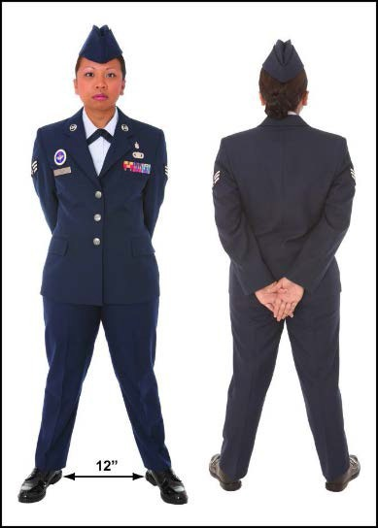
- Upon hearing the command of execution, “Rest”, lift the left leg from the hip just high enough to clear the ground.
- Keeping legs straight but not stiff, smartly move the left foot out to the left and place it down approximately 22 ½ degrees off the center line of the body.
- Heels are on line and about 12 inches apart, as
measured from the inside heel.
- Simultaneously, bring the hands to the back of the body, taking the most direct route, uncapping them in the process.
- Extend and join your fingers pointing them down toward the ground; palms out.
- Place the back of the right hand into the palm of the left hand, with the right thumb over the left so that thumbs form an “X”.
- Keep arms fully extended pointing down.
- Keep head and eyes forward, maintaining silence and immobility until given your next command.

DRESS RIGHT DRESS
Purpose: The “dress right dress” is the military way of aligning a flight in Line Formation.
Preparatory Command: “Dress Right” “Ready”
Command of Execution: “Dress” “Front”
Requirements for Movement: You must be halted at the position of attention; in Line Formation, at Normal Interval, in the Cadence of Quick Time, and is executed with snap and pop. Count Off should be performed prior to this movement, however for this 30-command drill sequence it is omitted.

Procedures to Perform:
- Upon hearing the preparatory command of “Dress Right”, form a mental picture of what is about take place; do not move.
- When you hear the command of execution, “Dress”, raise and extend your left arm laterally from the shoulder with snap.
- At approximately waist level, uncup your hand, extend and join your fingers, and place your thumb along the forefinger.
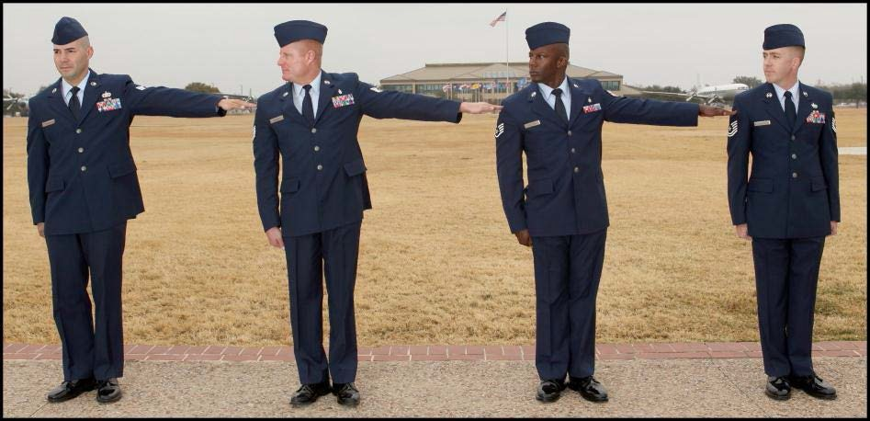
- Keeping your palm facing down, continue raising your arm until it is parallel to the ground. Simultaneously, turn your head 45-degreesto the right with snap.

Dress, Cover, Interval and Distance (DCID) Responsibilities:

- Second, third, and fourth element leaders take short, choppy steps to cover directly behind the cadet in front of them and establish an approximate 40-inch distance.
- The leading individual in each file takes short, choppy steps to dress to the right and establish normal interval by obtaining shoulder-to-fingertip contact with the cadet to their immediate right.
- The remaining cadets in the second, third and fourth elements take short choppy steps to dress to the right and cover directly behind the cadet in front of them using their peripheral vision (looking out of the corner of their left eye).

DRESS RIGHT DRESS CONTINUED

Exceptions:
- Second, third, and fourth element leaders will not turn their head and eyes 45-degreesto the right but will still raise their left arms. If using a guide-on – the first element leader will turn their head to the right to dress on the guide-on bearer.
- The last cadet in each element will not raise their left arm, but will still turn their head and eyes 45-degreesto the right with snap.

Long Arm-Short Arm Rule:
- If you are in the second, third, or fourth element and your arm is too long, place your hand behind the cadet to your left, arm parallel to the ground.
- If your arm is too short, leave your arm and hand extended, parallel to the ground.

Procedures to Perform (continued):
- You will maintain this position until you are properly aligned and you receive the next command, which will be “Ready, Front”.
- Upon hearing the preparatory command of “Ready”, form a mental picture of what is about to take place, maintaining your current position.
- When you hear the command of execution, “Front”, smartly lower your hand, retracing the path you used to raise it and cup your hand as it passes the waist, returning your hand to your side without slapping. Simultaneously, with snap, turn your head and eyes to the front.
- You are now back at the position of attention where you will remain until you receive your next command.

OPEN RANKS
Purpose: “Open ranks” is the military way of spreading and aligning a flight in Line Formation.
Preparatory Command: “Open Ranks” “Ready”
Command of Execution: “March” “Front”
Requirements for Movement: You must be halted at the position of attention; in Line Formation, at Normal Interval, in the Cadence of Quick Time, and is executed with snap and pop.

Procedures to Perform:
The flight commander (FC) should be six paces away and facing the flight. Upon giving the command of execution march, the FC should step off toward the anticipated finishing spot of the guide-on bearer to start the aligning procedures.
- On “March”, the fourth element will stand fast and automatically execute dress right dress.
- Each element in front of the fourth element takes the required number of paces, stepping off with the left foot and coordinated arm-swing, halts, and automatically executes dress right dress.
- The third element takes one pace, the second element takes two paces, and the first element takes three paces forward.
- Once halted, the distance between elements will be 64 inches.
- Once the flight is aligned, you will receive the next command, which will be “Ready, Front”.
- On “Front”, everyone will return their heads and eyes back to the front with snap, and return their arms to their sides without slapping.
- The position of attention has been resumed, which is where you will remain until you receive your next command.
- Once the flight commander has completed aligning the 4th element, they will proceed back to toward the guide-on bearer taking three paces past the guide-on bearer, halt and then execute a left face. This is where the flight commander will call “Ready Front”.

CLOSE RANKS
Purpose: “Close ranks” is the military way of closing a flight in Line Formation after doing Open ranks.
Preparatory Command: “Close Ranks”
Command of Execution: “March”
Requirements for Movement: You must be halted at the position of attention; in Line Formation, at Normal Interval, in Open Ranks, in the Cadence of Quick Time, and is executed with snap and pop.

Procedures to Perform:
If no inspection procedures take place, the Flight Commander upon giving their flight Ready Front, should take one step forward placing themselves in front of the guide-on bearer and looking down line to give the command “Close Ranks March”.
- On “March”, the first element stands fast.
- The second element takes one pace forward with coordinated arm-swing and halts at the position of attention.
- The third and fourth elements take two and three paces forward, respectively, and halt at attention.
- The flight has returned to normal DCID, where you will remain until you receive your next command.

Once the flight has completed Close Ranks March, the Flight Command gives parade rest, at ease, or rest (whichever is appropriate), and posts in front of and centered on the flight.
PRESENT ARMS/ORDER ARMS
Purpose: The salute is the military way of exchanging courteous greetings
Preparatory Command: “Present” “Order”
Command of Execution: “Arms” “Arms”
Requirements for Movement: You must be halted at the position of attention. This movement can be done as a single individual or with an entire flight. It can be any formation, at Close or Normal Interval, in the Cadence of Quick Time, and is executed with snap and pop.

Procedures to Perform:

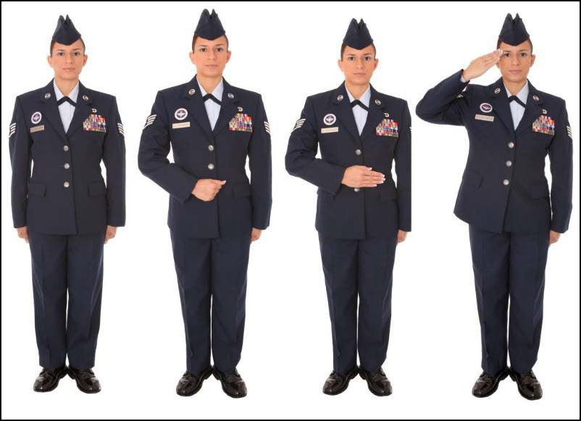
  - The command “Present, Arms”. On “Arms”, the entire flight will perform a salute.
  - The Salute is done in one count. On the command “Arms” the individual raises the right hand smartly in the most direct manner while at the same time extending and joining the fingers. Keep the palm flat and facing the body. Place the thumb along the forefingers, keeping the palm flat
and forming a straight line between the fingertips and elbows. Tilt the palm slightly toward the face. Hold the upper arm horizontal, slightly forward of the body and parallel to the ground. Ensure the tip of the middle finger touches the right front corner of the headdress.
- If wearing a non-billed hat, ensure the middle finger touches the outside corner of the right eyebrow or the front corner of glasses. The rest of the body will remain at the position of attention.
- To complete Order Arms, bring the arm smoothly and smartly downward, retracing the path used to raise the arm. Cup the hand as it passes the waist, and return to the position of attention.

LEFT FACE
Purpose: The “left face” is the military way of turning 90-degreesto the left from a halt.
Preparatory Command: “Left”
Command of Execution: “Face”
Requirements for Movement: You must be halted at the position of attention. This movement can be performed as a single individual or with an entire flight. This movement can be performed in any formation, at Close or Normal Interval, in the Cadence of Quick Time, and is executed with snap and pop.

Procedures to Perform:
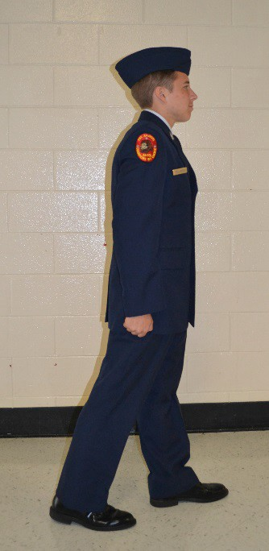
  - Upon hearing the preparatory command of “Left”, form a mental picture of what is about to take place; do not move.
  - When you hear the command of execution, “Face”, raise your left toe and right heel high enough to clear the ground, without bending the knees.
  - Next, turn 90-degreesto the left on the ball of the right foot and the heel of the left foot, assisted by the slight pressure on the ball of the right foot. Keep the upper body at the position of attention.
  - After pivoting 90-degreesto the left, plant your left foot 22 ½ degrees off the centerline of the body. Keep both legs straight, but not stiff. Again, the upper body remains at the position of attention. [This completes count one of a two- count movement]
  - To complete count two, bring your trailing foot (right) smartly forward the most direct route, back to the position of attention so your heels come together and on line and your feet form a 45-degree angle.
  - Heels should be on line and feet should now be forming a 45-degree angle, which means the position of attention has been resumed. [This completes count two of the movement]

ABOUT FACE
Purpose: The “about face” is the military way of turning 180 to the rear from a halt.
Preparatory Command: “About”
Command of Execution: “Face”
Requirements for Movement: You must be halted at the position of attention. This movement can be performed as a single individual or with an entire flight. This movement can be performed in any formation, at Close or Normal Interval, in the Cadence of Quick Time, and is executed with snap and pop.

Procedures to Perform:
- Upon hearing the preparatory command of “About”, form a mental picture of what is about to take place; do not move.
- When you hear the command of execution, “Face”, lift the right foot from the hip just enough to clear the ground. Without bending the knees, place the ball of the right foot approximately half a shoe length behind and slightly to the left of the heel.
- Distribute the weight of the body on the ball of the right foot and heel of the left foot. Keep both legs straight
but not stiff. The position of the foot has not changed. [This completes count one of a two-count movement]
- To complete count two, keeping the upper body at the position of attention, pivot 180 degrees to the right on the ball of the right foot and heel of the left foot, with a twisting motion from the hips. Suspend arm- swing during the movement, and remain as though at attention.
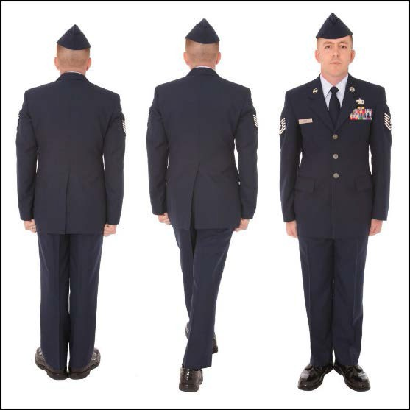
- On completion of the pivot, heels should be together and on line and feet should form a 45-degree angle. The entire body is now at the position of attention. [This completes count two of a two-count movement]

RIGHT FLANK
Purpose: The “right flank” is the military way of turning an entire formation 90-degreesto the right while marching.
Preparatory Command: “Right Flank”
Command of Execution: “March”
Requirements for Movement: You must be marching at the position of attention. This movement can be performed as a single individual or with an entire flight.
This movement can be performed in any formation, at Close or Normal Interval, in the Cadence of Quick Time, and is executed with snap and pop.

Procedures to Perform:
- The preparatory command will be given as the heel of the right foot strikes the ground. Upon hearing the preparatory command of “Right Flank”, form a mental picture of what is about to take place and continue to march.
- When the heel of the left foot strikes the ground, you will not hear anything; continue to march.
- When the heel of the right foot strikes the ground again, you will hear the command of execution, “March”. On “March”, everyone takes one more 24-inch step with the left foot with coordinated arm-swing.
- As the weight of the body comes forward on the ball of the left foot, suspend arm-swing.
- Next you will pivot 90-degreesto the right stepping out with the right foot with a full 24-inch step, resuming coordinated arm-swing and maintaining DCID throughout the movement.

LEFT FLANK
Purpose: The “left flank” is the military way of turning an entire formation 90-degreesto the left while marching.
Preparatory Command: “Left Flank”
Command of Execution: “March”
Requirements for Movement: You must be marching at the position of attention. This movement can be performed as a single individual or with an entire flight.
This movement can be performed in any formation, at Close or Normal Interval, in the Cadence of Quick Time, and is executed with snap and pop.

Procedures to Perform:
- The preparatory command will be given as the heel of the left foot strikes the ground. Upon hearing the preparatory command of “Left Flank”, form a mental picture of what is about to take place and continue to march.
- When the heel of the right foot strikes the ground, you will not hear anything; continue to march.
- When the heel of the left foot strikes the ground again, you will hear the command of execution, “March”. On “March”, everyone takes one more 24-inch step with the right foot with coordinated arm-swing.
- As the weight of the body comes forward on the ball of the right foot, suspend arm-swing.
- Next you will pivot 90-degreesto the left stepping out with the left foot with a full 24-inch step, resuming coordinated arm-swing and maintaining DCID throughout the movement.

COLUMN RIGHT

Purpose: The “column right” is the military way of turning the head of a formation 90-degreesto the right while marching.
Preparatory Commands: “Column Right” “Forward
Command of Executions: “March” “March”
Requirements for Movement: You must be marching at the position of attention. You must be in Column Formation. It is done in the Cadence of Quick Time, and is executed with snap and pop.

Procedures to Perform: (Entire Flight)
- The preparatory command will be given as the heel of the right foot strikes the ground. Upon hearing the preparatory command of “Column Right”, form a mental picture of what is about to take place and continue to march.
- When the heel of the left foot strikes the ground, you will not hear anything; continue to march.
- When the right foot strikes the ground again, you will hear the command of execution, “March”

3rd Element Leader:
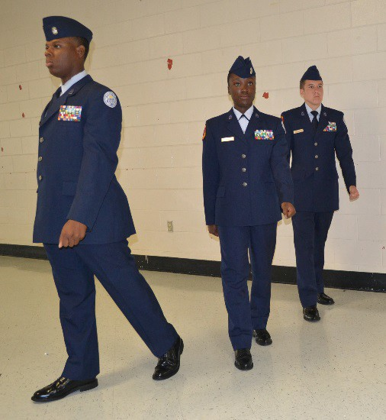
24-inch step
1. On “March, he/she will take one more 24-inch step with the left foot.

2. As the weight of the body comes forward, suspend arm-swing and pivot 90-degreesto the right on the ball of the left foot.

3. Following the pivot, immediately take one 24-inch step with the right foot and resume coordinated arm-swing.

4. Without scraping the ground, begin half-step (12-inch step) with the left foot.

NOTE: Picture reflects the position of each element leader after the first pivot.

COLUMN RIGHT CONTINUED

2nd Element Leader: (pivots with coordinated arm-swing)

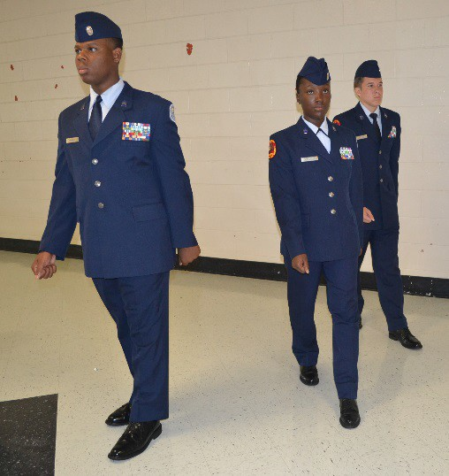
12-inch step
24-inch step
1. On “March”, he/she will take one more 24-inch step with the left foot.

2. As the weight of the body comes forward, pivot 45-degreesto the right on the ball of the left foot.

3. Following the first pivot, take two 24- inch steps and pivot again 45-degreesto the right.

4. Following the second pivot, continue in 24-inch steps until abreast of the 3rd element leader; begin half-step, establish interval, and dress to the right.

Remainder of the 2nd Element: (pivots with coordinated arm-swing)
1. On “March”, the remainder of the 2nd element will march straight ahead to the approximate pivot point established by the person in front of them.

2. When they come to the pivot point, they take one more 24-inch step with the left foot.

3. As the weight of the body comes forward, pivot 45-degreesto the right on the ball of the left foot.

4. Following the first pivot, take two 24-inch steps and pivot again 45-degreesto the right.

5. Following the second pivot, continue in 24-inch steps until abreast of the person that normally marches to their right; begin half-step, cover, and dress to the right.

COLUMN RIGHT CONTINUED

1st Element Leader: (pivots with coordinated arm-swing)
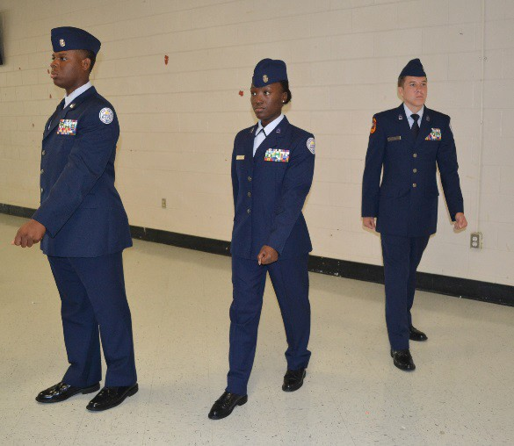
1. On “March”, he/she will take one more 24- inch step with the left foot.

2. As the weight of the body comes forward, pivot 45-degreesto the right on the ball of the left foot.

3. Following the first pivot, take four 24-inch steps and pivot again 45-degreesto the right.

4. Following the second pivot, continue in 24- inch steps until abreast of the 2nd element leader; begin half-step, establish interval, and
dress to the right.
24-inch step
24-inch step
12-inch step

Remainder of the 1st Element: (pivots with coordinated arm-swing)
- On “March”, the remainder of the 1st element will march straight ahead to the approximate pivot point established by the person in front of them.
- When they come to the pivot point, they take one more 24-inch step with the left foot.
- As the weight of the body comes forward, pivot 45-degreesto the right on the ball of the left foot.
- Following the first pivot, take four 24-inch steps and pivot again 45-degreesto the right.
- Following the second pivot, continue in 24-inch steps until abreast the person that normally marches to their right; begin half-step, cover, and dress to the right.

COLUMN RIGHT CONTINUED

After Entire Flight has Completed Pivot(s):

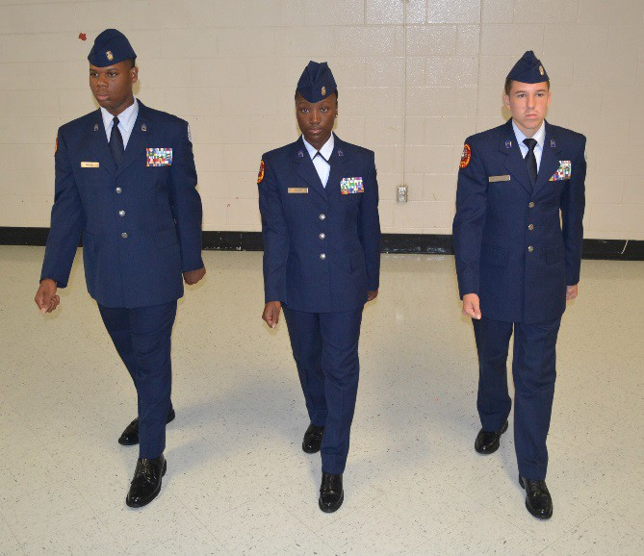
  - Now the entire flight is marching in
half-step, and has established DCID. “Forward, March” is the only command allowed at this time.

  - The preparatory command, “Forward”, will be given as the heel of the left foot strikes the ground. Upon hearing the preparatory command, form a mental picture of what is about to take place and continue to march in half-step.

  - When the right foot strikes the ground, you will not hear anything.

  - When the left foot strikes the ground again, you will hear the command of execution, “March”.

  - On “March”, everyone will take one more 12-inch step with the right foot, then step off with a 24-inch step on the left foot.

When marching with a guide they perform the pivots and steps exactly as the third (or fourth element) element leader. Following completion of the pivots, the guide continues in a 24-inch step until he or she is ahead of the fourth (third) element leader. The guide pivots 45-degrees to a position in front of the fourth (third) element leader; then he or she pivots 45-degrees again toward the front and begins half stepping.

TO THE REAR
Purpose: The “to the rear” is the military way of turning an entire formation 180 degrees to the rear while marching.
Preparatory Command: “To The Rear”
Command of Execution: “March”
Requirements for Movement: You must be marching at the position of attention. This movement can be performed as a single individual or with an entire flight.
This movement can be performed in any formation, at Close or Normal Interval, in the Cadence of Quick Time, and is executed with snap and pop.

Procedures to Perform:
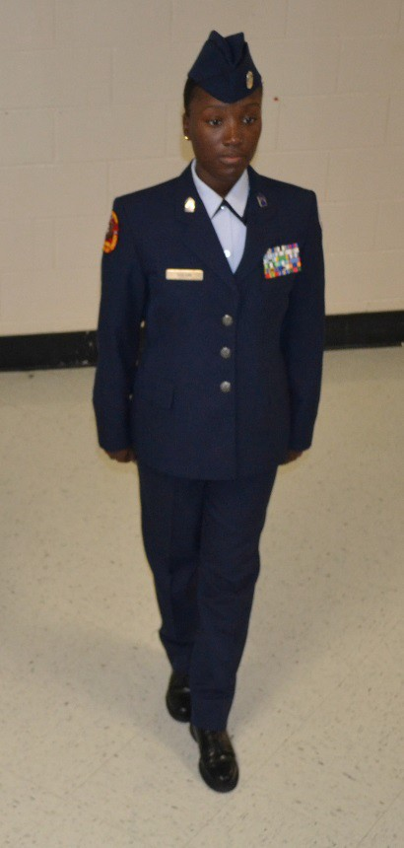
  - The preparatory command will be given as the heel of the right foot strikes the ground. Upon hearing the preparatory command of “To The Rear”, form a mental picture of what is about to take place and continue to march.
  - When the heel of the left foot strikes the ground, you will not hear anything; continue to march.
  - When the heel of the right foot strikes the ground again, you will hear the command of execution, “March”. On “March”, everyone takes a 12-inch step with the left foot with coordinated arm-swing, and place it in front of and in line with the right foot, distributing the weight of the body on both feet.
  - Next you will pivot on the balls of both feet, turning 180 degrees to the right and suspending your arm-swing as you perform the pivot. Do not force the body up or lean forward. The arm-swing is suspended to the sides as the weight of the body comes forward while executing the pivot, as if at the position of attention. The pivot takes a full count.

TO THE REAR CONTINUED

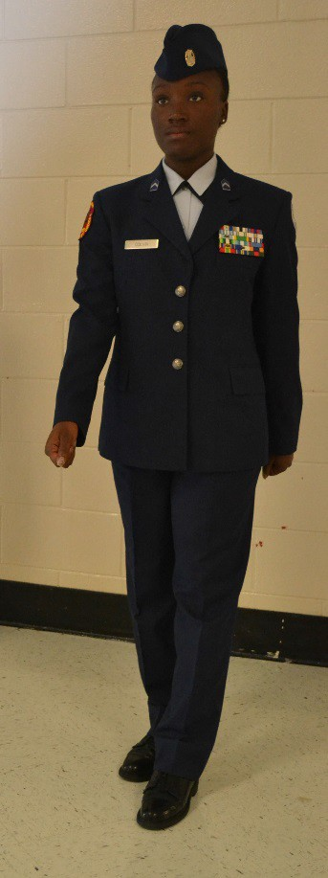
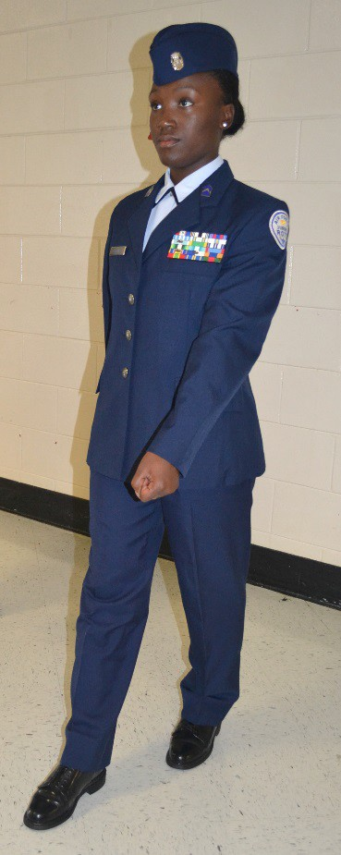
  - Following the pivot, you will take a 12-inch step with the left foot in the new direction, with coordinated arm-swing, before taking a full 24-inch step with the right foot, maintaining DCID throughout the movement.
The half-step. Measure the 12-inch step from the heel of the right foot to the heel of the left foot.

A teaching technique for your cadets: In line, pivot, 12, 24, left, right, left.
Note: That during the
12-inch step (half step) the cadet has coordinating arm swing at this point.

EYES RIGHT/READY FRONT
Purpose: “Eyes Right” is the military way of acknowledging the senior officer during a parade or review.
Preparatory Command: “Eyes” “Ready”
Command of Execution: “Right” “Front”
Requirements for Movement: You must be halted or marching at the position of attention, at Normal Interval, Column Formation, in the Cadence of Quick Time, and is executed with snap and pop.

Procedures to Perform:
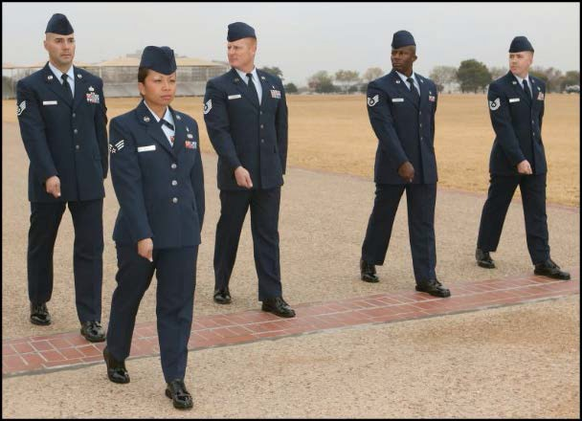
    - Eyes Right - The preparatory command and command of execution are given on the right (since movement is to the right) foot while marching.

    - On the command RIGHT, all persons, except those on the right flank, turn their heads and eyes smartly 45-degrees to the right.

    - The Flight Commander on the command RIGHT will turn their head to the right and simultaneously executes and holds a salute until the next command.

    - To return their heads and eyes to the front, the command Ready, FRONT is given as the left foot strikes the ground.

    - On the command FRONT, heads and eyes are turned smartly to the front.

    - The Flight Commander on the command FRONT will drop their salute simultaneously returning their head looking forward.

    - The entire flight is now marching at the position of attention which will continue until the next command is given.

CHANGE STEP
Purpose: The “change step” is the military way of changing your step while marching.
Preparatory Command: “Change Step”
Command of Execution: “March”
Requirements for Movement: You must be marching at the position of attention. This movement can be performed as a single individual or with an entire flight.
This movement can be performed in any formation, at Close or Normal Interval, in the Cadence of Quick Time, and is executed with snap and pop.

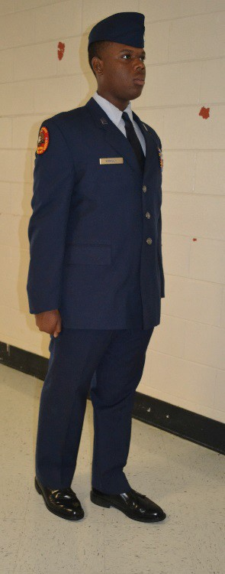
Procedures to Perform:
  - The preparatory command will be given as the heel of the right foot strikes the ground. Upon hearing the preparatory command of “Change Step”, form a mental picture of what is about to take place and continue to march.
  - When the heel of the left foot strikes the ground, you will not hear anything; continue to march.
  - When the heel of the right foot strikes the ground again, you will hear the command of execution, “March”. On “March”, everyone takes one 24-inch step with the left foot with coordinated arm-swing.
  - Next, in one count, you will place the ball of the right foot alongside the heel of the left foot and suspend arm- swing, without rising up or leaning forward or to the side.
  - Now, you will transfer the weight of your body to the right foot and immediately step off with the left foot in a 24-inch step and resume arm- swing.
  - Your upper body remains at Attention while maintaining DCID throughout the movement.

Teaching technique. Have cadets think “step-pause-step”. They step with the left, there is a very slight pause when bringing in the right foot next the left heel to transfer the weight and then step with the left foot. Emphasize there is no skipping, hopping, jumping or scraping of shoes on the ground when performing this movement.
RIGHT STEP
Purpose: The “right step” is the military way of moving a formation short distance to a given flank from a halt.
Preparatory Command: “Right Step” “Flight”
Command of Execution: “March” “Halt”
Requirements for Movement: You must be halted at the position of attention. This movement can be performed as a single individual or with an entire flight. This movement can be performed in any formation, at Close or Normal Interval, in the Cadence of Quick Time, and is executed with snap and pop.

Procedures to Perform:
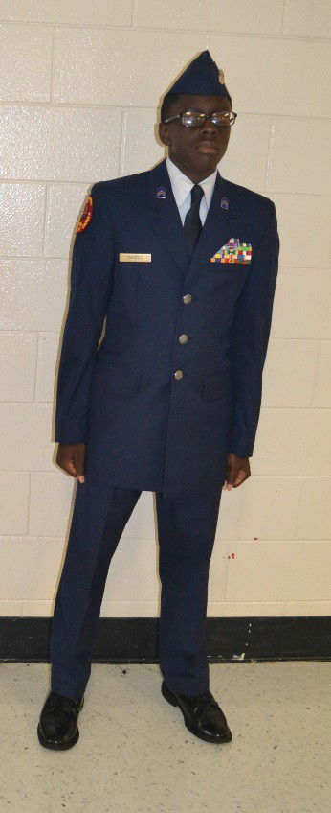
    - While at the position of attention, you will receive the
preparatory command of “Right”. Form a mental picture of what is about to take place and remain at attention.
    - Upon hearing the command of execution, “March”, lift the right leg from the hip just high enough to clear the ground.
    - Keeping the leg straight, but not stiff, place the right foot 12 inches, as measured from inside the heels, and place it 22 ½- degrees off the center line of the body.
    - Next, transfer the weight of the body to the right foot, and without scraping the ground, smartly bring the left foot alongside the right as in the position of attention.
    - This movement is continued in Quick Time, and the upper body remains at attention throughout.
    - The only command allowed to be given at this time is “Flight, Halt”.
    - When the preparatory command of “Flight” is received, your heels will be together (in transition). Form a mental picture of what is about to take place and continue the movement.
    - After the next step, when the heels come together again, you will hear the command of execution, “Halt”.
    - On “Halt”, take one more 12-inch step to the right, then bring the heels together.
    - The position of attention has been resumed, where you will remain until you receive your next command.

